1. **How to unlock/forgotten password using a cellphone**

**Step 1:** On your browser type <https://sspr.eskom.co.za>

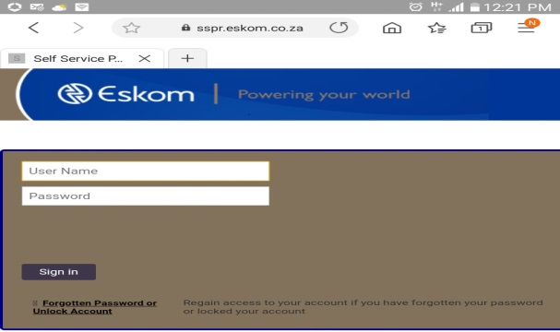

**Step 2:** click on “Forgotten Password or Unlock Account” and enter username

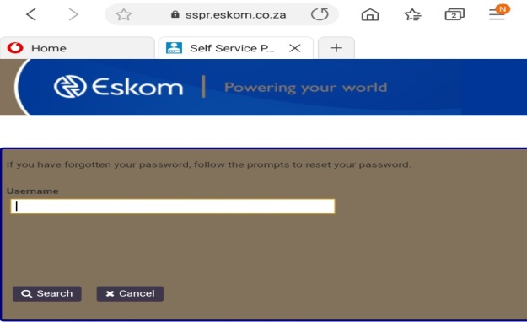

**Step 3:** click on “Email or SMS”

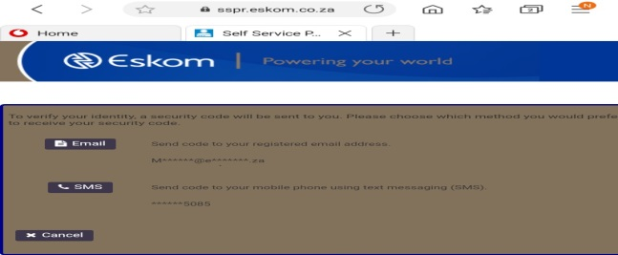

**Step 4:** Enter the code sent to your email or phone and set a new password.

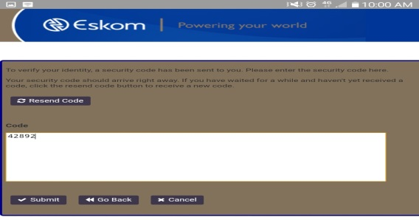

1. **How to update cellphone number**

**Step 1:** On your browser type <https://sspr.eskom.co.za>



**Step 2:** Type your username and password to sing in

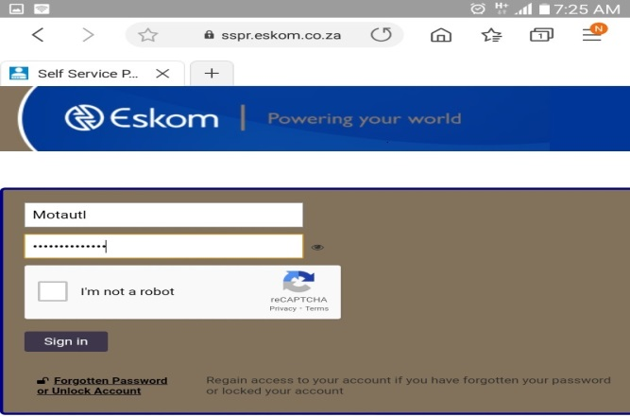

**Step 3:** You can make a selection on the below Menu and follow instructions.

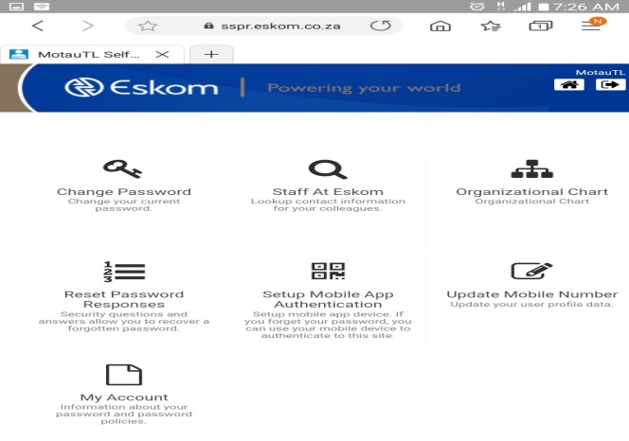

1. **How to setup APN on windows 10**

**Step 1:** click on "elec.eskom.co.za Internet access (button)"

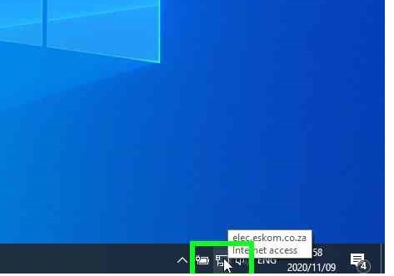

**Step 2:** click on "Vodacom SA (UMTS) Disconnected

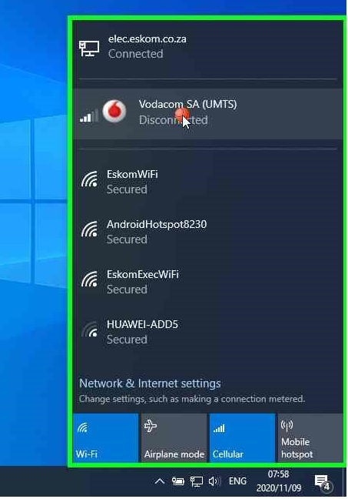

**Step 3:** click on "Connect (button)"

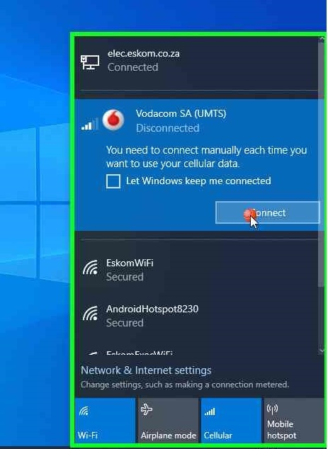

**Step 4:** click on "Network & Internet settings (text)"

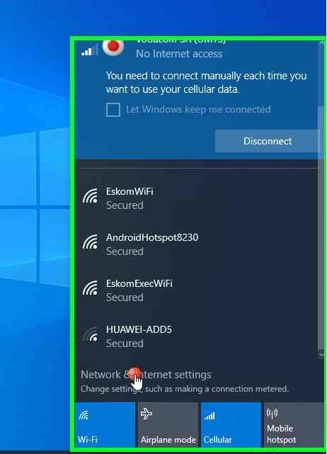

**Step 5:** click on "Cellular (text)"

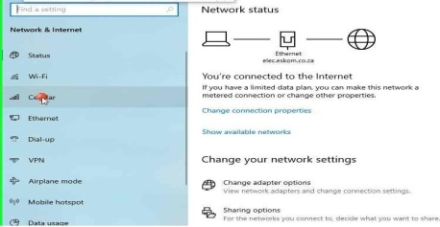

**Step 6:** click on "Advanced options (text)"

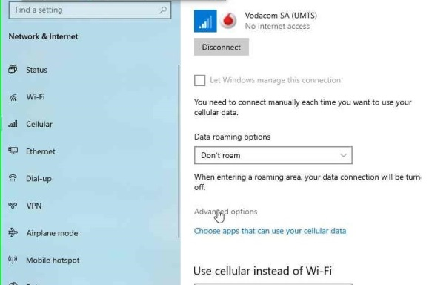

**Step 7:** click on "APN settings (group)"

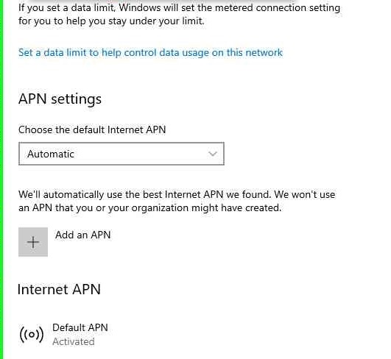

**Step 8:** keyboard input on "Settings (window)"Profile name=Eskom APN=Eskom1

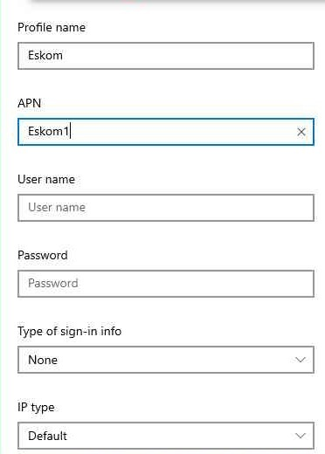

**Step 9:** click on "Save (button)"

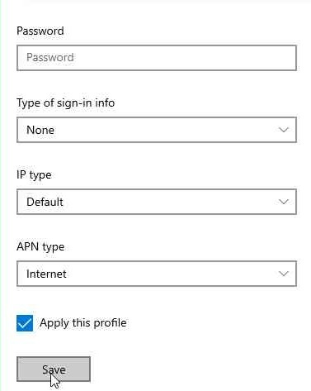

1. **How to send large files on email**

**Step 1:** Open Mozilla Firefox and type <https://zendto.eskom.co.za/>

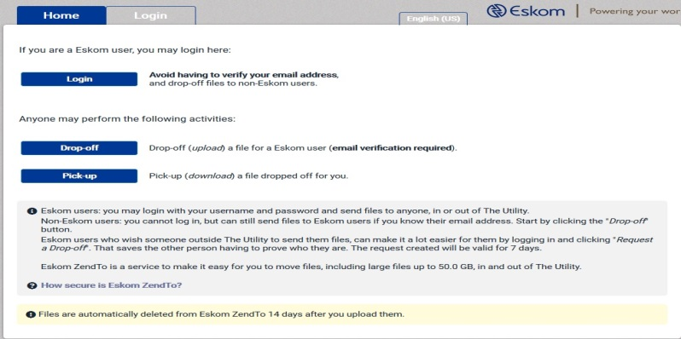

**Step 2:** Click on Login and follow easy steps.